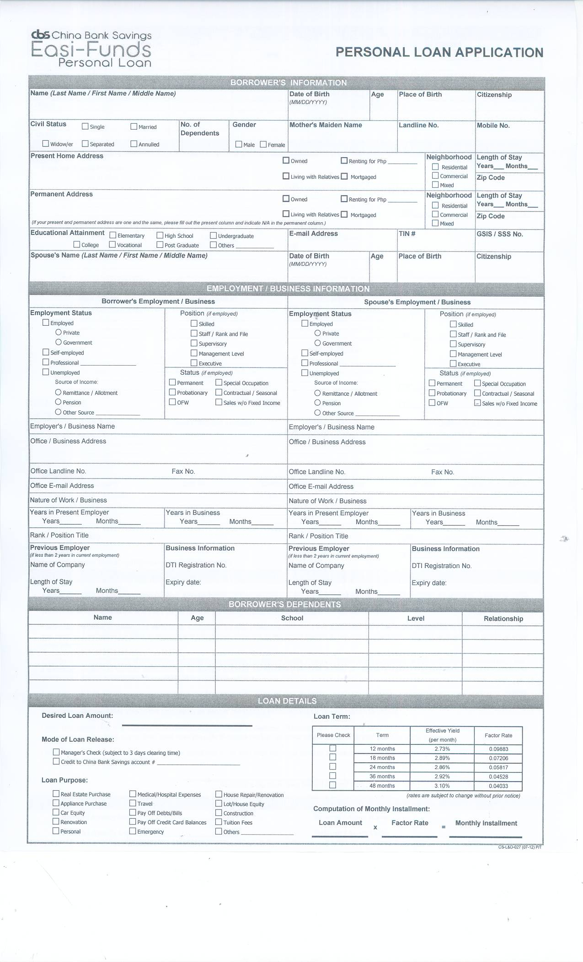

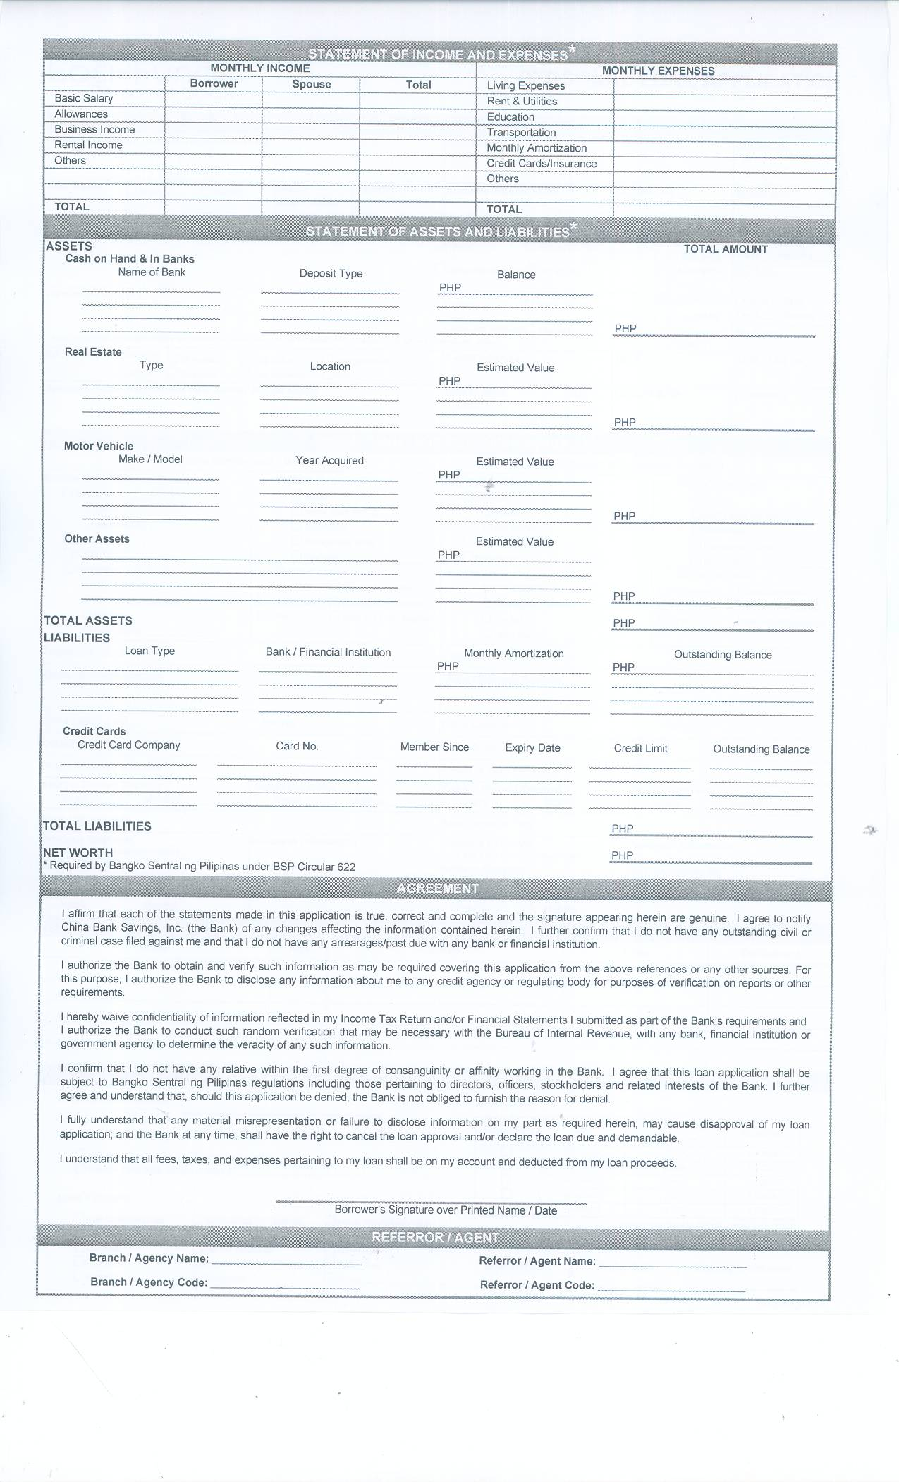

**CHINABANK SAVINGS**

Qualifications:  
1. Filipino Citizens  
2. Employed / Self Employed  
3. Between 21 to 55 years old at the time of application  
4. Principal Credit Cardholder  
5. With landline at the place of business  
6. With landline or mobile at the place of residence  
7. Earning at least Php 30,000 per month or Php 360,000 per annum  
8. Tenure  
        a. Employed - 2 years permanent employee (at least 1 year at  
  current)  
        b. Self Employed ? business is at least 3 years in existence  
  
Requirements:  
1. Completely filled out application form signed by the borrower  
2. Photocopy company ID bearing photo and signature and  
3. Photocopy of any one (1) valid Government issued photo id bearing  
signature (2 ID's if Self Employed)  
      a. Passport  
      b. Drivers License  
      c. Tin ID (digitized)  
      d. GSIS / SSS ID  
      e. PRC ID  
      f. Voter's ID  
      g. NBI ID (digitized)  
      h. Firearms License  
      i. Unified Multi-Purpose ID  
4. Income Documents  
      a. Employed - photocopy latest 3 months payslip or latest ITR  
      b. Self Employed - photocopy latest 2 years ITR with matched AFS and  
latest 3 months Bank Statements  
5. Photocopy latest Credit Card billing Statement  
6. Photocopy of DTI registration or SEC papers (for Self Employed)  
7. List of 3 Customers and Suppliers with contact details (for Self  
Employed, if applicable)  
  
Features:  
1. Loan Amount  
      a. Minimum ? Php 20,000  
      b. Maximum ? Php 500,000  
2. Loan Term & Interest  
        |--------+-----------+-----------|  
        | Tenor  |    EY    |Factor Rate|  
        |--------+-----------+-----------|  
        |  12  |  32.73%  |  0.09883  |  
        |--------+-----------+-----------|  
        |  18  |  34.72%  |  0.07206  |  
        |--------+-----------+-----------|  
        |  24  |  34.33%  |  0.05817  |  
        |--------+-----------+-----------|  
        |  36  |  35.07%  |  0.04528  |  
        |--------+-----------+-----------|  
        |  48  |  37.24%  |  0.04033  |  
        |--------+-----------+-----------|  
  
  
3. Loan Repayment ? Post Dated Checks  
4. Loan Release  
      a. Credited to your Chinabank Savings Account  
      b. MC deposited to your other Bank Account (subject to 3 days  
clearing time)

5. Fee's  
      a. Processing ? Php 1,500  
      b. Doc Stamps ? Php 1.0 for every Php 200 of the approved loan amount  
(including interest) or a fractional part thereof for PN's greater than Php  
250,000

TO APPLY: Simply send your requirements via email & have it attn to Jaypee

**For more details please call:**

###### Jerson Oledan

**Tel No.: 5659347**

**Mobile No.: 09205594555 /**

**09226122298 /**

**09177865592**